Yearly Time Administration
V25
CoreHR Confidential
Core Time

1. Overview 3
2. How to Complete the Scenario 4
2.1. Extend System Calendar 4
2.1.1. Prerequisites 4
2.1.2. Data Required 4
2.1.3. Steps to Complete – Extend System Calendar 4
2.1.4. Outcome 6
2.2. Update Holiday Scheme Details 7
2.2.1. Prerequisites 7
2.2.2. Data Required 7
2.2.3. Steps to Complete 7
2.2.4. Outcome 8
2.3 Extend Balance Calendar 9
2.3.1. Prerequisites 9
2.3.2. Data Required 9
2.3.3. Steps to Complete – Extend System Calendar 9
2.3.4. Outcome 10
2.4. Complete Balance Period End 11
2.4.1. Prerequisites 11
2.4.2. Data Required 11
2.4.3. Steps to Complete – Complete Balance Period End 11
2.4.4. Outcome 12

Overview
The following processes are part of the yearly administration that is required to keep the CoreTime system up to date. The administration of yearly time processes is the task for the CoreTime Administrator.

This document outlines how to:
- Extend the CoreTime System Calendar
- Update Holiday Scheme details
- Extend a Balance Calendar
- Complete the Balance Period End

How to Complete the Scenario

Extend System Calendar
The CoreTime System Calendar must be extended each year to cover the next calendar year. Before extending the System Calendar for a CoreTime Company, please check and make note of the following items (per T&A Company):
- Start day of the T&A Company (e.g. Monday)
- Last period configured on the T&A System Calendar (e.g. 201452 22 Dec 2014 - 28 Dec 2014)

Prerequisites
- User must have an active CoreHR Back Office account.
- Calendar exists in CoreHR

Data Required
- Start Day of the CoreTime Company e.g. Monday
- Last Period configured on the Calendar e.g. 201852 24 Dec 2018 – 30 Dec 2018)
- Number of weeks in the year

Steps to Complete – Extend System Calendar
Login to CoreTime back office
- User logs on to CoreHR back office.
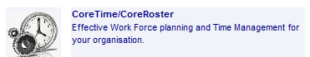
- Navigate to CoreTime menu.

Extend Company Calendar
- Navigate to System Params > Calendars > System Calendar.
- Use List of Values to select the Company calendar to extend.
- Click ‘Calendar Years’ to view define the upcoming year.
- Scroll to end of years listing, click last year listed, then + to add a new row. Enter the upcoming year’s details:
- Year - Enter the year number for the new calendar year that you are configuring e.g. 2019
- Start Date. The start date must correspond to the 'Start Day' configured for the CoreTime Company. For example, if the start day of the T&A Company is 'Monday' then the start date must be a Monday. The start date of the new calendar year must be exactly one week after the start date of the last period of the previous year. It is important to ensure that all weeks are covered i.e. that there isn't a gap between the end of one year and the start of the next.
- No. of Weeks. Specify the number of weeks in this year e.g. 52 or 53.
- Click ‘Save’.
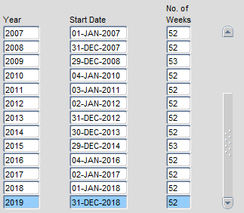
- Click 'Calendar Periods'.
- Click ‘Generate Period’. Enter End Period for year just added e.g. 201952 and press enter to auto-populate Start Date and End Date for the final period of the newly added year.
- Click ‘OK’ to automatically generate all Periods.
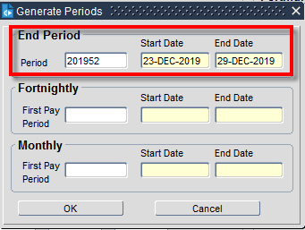
- Click Save to save new year.
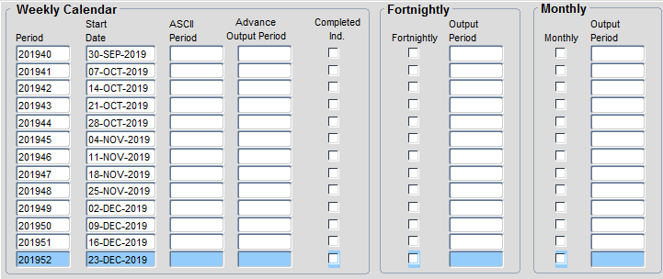

Outcome
- Company System Calendar extended.

Update Holiday Scheme Details
In the following section, it details how to enter ‘Company Holidays e.g. Bank Holidays prior to the calendars moving forward. This needs to be completed at the beginning of each year.

Prerequisites
- User must have an active CoreHR HR Back Office account.
- Company Holiday scheme exists in CoreHR

Data Required
- Company/Public Holiday dates for the new year

Steps to Complete
Login to CoreTime back office
- User logs on to CoreHR back office.

- Navigate to CoreTime menu.

Extending Company Holiday Schemes
- Navigate to System Params > Holiday Schemes > Company Holiday Details
- Use ? List of Values to display existing details for the chosen Holiday Scheme.
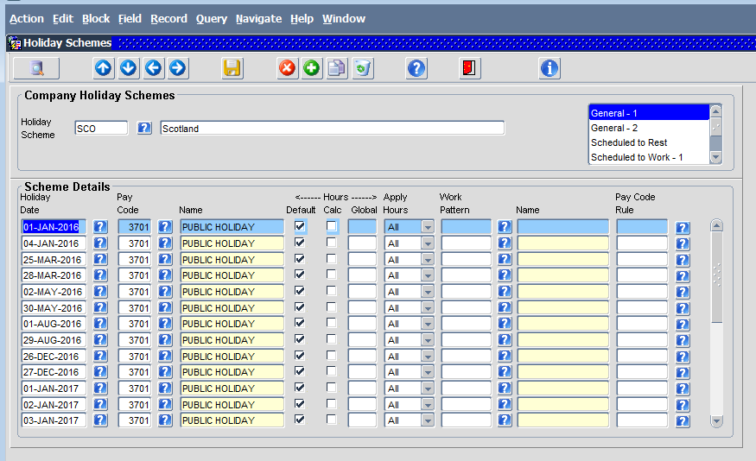
- Use to add holiday details:
- Holiday Date e.g. 25-Dec-2018
- Pay Code e.g. 3701 for standard Public Holiday
- Tick ‘Default’.
- Repeat for all Holiday Dates and click  to save.
- Repeat for all Holiday Schemes.

Outcome
- Company Holiday scheme updated for the upcoming year.

2.3 Extend Balance Calendar
Balances (e.g. Annual Leave, Study Leave) have accompanying calendars that exist independently of the System Calendar. These must be extended each year to cover the next calendar year. For example, if Annual Leave is managed in yearly blocks the Annual Leave balance calendar defines the start date and end date of each leave year (period) and specifies any carry forward rules. It is not possible to close a balance period (complete a period end) until the next period has been configured on the balance calendar.

2.3.1. Prerequisites
- User must have an active CoreHR Back Office account.
- Balance Calendar exists in CoreHR

2.3.2. Data Required
- Last Period configured on the Calendar e.g. 2018 01 Jan 2018 – 31 Dec 2018)

2.3.3. Steps to Complete – Extend System Calendar
Login to CoreTime back office
- User logs on to CoreHR back office.

- Navigate to CoreTime menu.

Extend Balance Calendar
- Navigate to System Params > Balances > Calendars.
- Use List of Values to select the Balance calendar to extend.
- Click + to add a new row and add required details:
- Period - Enter the balance period number. For yearly periods, specify '2019' for the year 2019, '2020' for the year 2020, etc. For shorter periods, specify '201901' for the first period in 2019, '201902' for the second period in 2019, etc. For example, 2019 for Annual Leave, 201901 for Time in Lieu
- Start Date - Specify the start date of the period (e.g. 01 Jan 2019 or 1 April 2019)
- End Date - Specify the end date of the period (e.g. 31-Dec 2019 or 31st March 2020)
- End of Period Limits Days – Max - If applicable, specify maximum number of days that can be carried forward into the next balance period. Make sure the 'Carried Forward' option is selected in the 'Controls' drop down. e.g. Carry forward max 5 days
- End of Period Limits Hours – Max - If applicable, specify maximum number of hours that can be carried forward into the next balance period. Make sure the 'Carried Forward' option is selected in the 'Controls' drop down e.g. Carried forward max 37.5 hours
- Click ‘Save’.

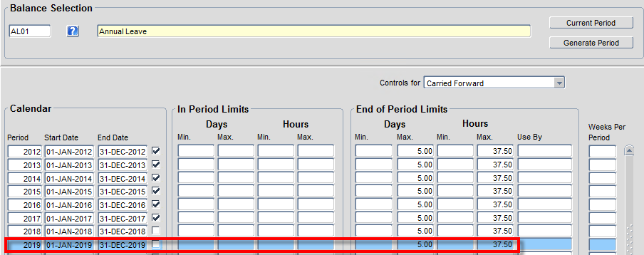
- Repeat for all Balances.

2.3.4. Outcome
- Balance Calendar(s) extended.

Complete Balance Period End
At the end of the entitlement/balance year, Balance Calendars must be closed to:
- Calculate new entitlements
- Apply Length of Service adjustments.
- Process carried forward values

The following steps outline how to complete a Balance Period end.

Prerequisites
- User must have an active CoreHR Back Office account.
- System Calendar is up to date.
- Balance Calendar exists in CoreHR
- Carried Forward limits applied to Balance Calendar
- Balance Calendar has been extended to at least one future Balance Period.
- Entitlements, Length of Service values up to date
- Balance Calendar Period is complete e.g. To close 2018 (1st Jan-31st Dec 2018), date must now be 2019
- UOX: reports have been run by HR staff of the outstanding leave balance for individuals before the rollover begins, so that leave carry over can be calculated and input.

Data Required
- Balance to be closed

Steps to Complete – Complete Balance Period End
Login to CoreTime back office
- User logs on to CoreHR back office.

- Navigate to CoreTime menu.

Balance Period End
- Navigate to Period End > Balance Period End.
- Use List of Values to select the Balance Calendar to complete.
- Confirm ‘Current Period’ is as expected.
- Click ‘View Thresholds’ to ensure Carried Forward limits are as expected. Click ‘x’ to close when confirmed.
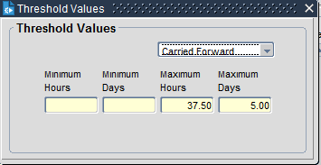
- To close Current Period, click ‘Run Period End’.
- Click ‘Yes’
- To override Carried Forward limits per individual employee, tick ‘Ignore’. (UOX: The University of Oxford configuration is currently for all balances to have 0 days leave carried over and any agreed carry over to be input by HR teams in the new year. There should be no need to ‘ignore’ any of the carried forward limits at this stage, this would be to allow a different (higher or lower) carry over limit for an individual than the limit set on the balance).
- Exit to complete Balance Period End.
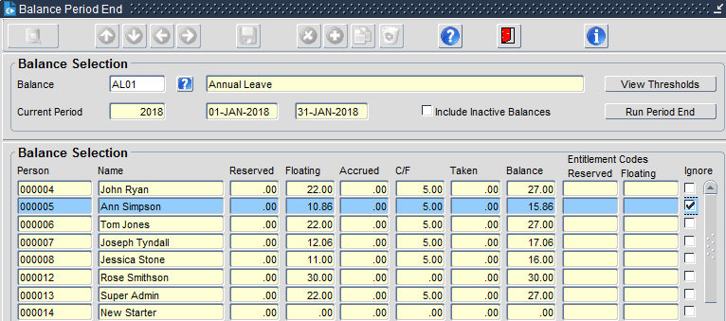
- UOX: To ensure that all employees can view their full entitlement once the rollover has been completed the following steps must be taken, or the overnight calculation processes should re-calculate balances for all staff.
- UOX: Navigate to CoreTime/CoreRoster > Time Mgt > Balances > Balance Recalculation
- UOX: For each balance, enter the balance code
- UOX: The From Period will auto-populate with the rolled over period and the relevant dates will display
- UOX: Select the “All” radio button at the bottom of the form
- UOX: Click “OK”
- UOX: The system will re-calculate all balances for the balance code selected. Do this for all balances which have been rolled over.

Outcome
- Balance Period end has been completed.
- New Balance Entitlements assigned to employees.
- Carried Forward values updated for employee Balances.

